|  |
| --- |
|  |
|  |

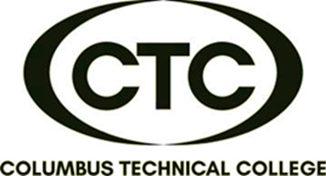

**This American Sign Language introductory course is designed to minimize communication barriers with individuals who are hard of hearing or deaf. It includes fundamentals such as fingerspelling, numbers, vocabulary, and grammar. At the end of the course, participants will be proficient in visual /gestural communication and have basic conversational skills.**

6:00 pm – 8:30 pm

Monday & Wednesday

CTC Training Center

5330 Transport Blvd.

Columbus, GA 31907

**CONTINUING EDUCATION CERTIFICATE**

**American Sign Language**

**24-Hour Course**

**(12 Sessions / 6 weeks)**

**\*\***

**DATES:**

**July 18 & 20**

**July 25 & 27**

**Aug. 1 & 3**

**Aug. 8 & 10**

**Aug. 15 & 17**

**Aug. 22 & 24**



**$235/person**

**(book included)**

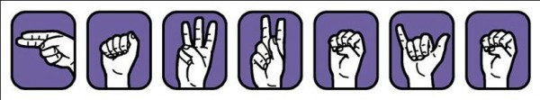

**American Sign Language Level I**

For more information or to register,

call Deana Beauford at **706-649-1454**

or email [**dbeauford@columbustech.edu**](mailto:dbeauford@columbustech.edu)