|  |
| --- |
|  |
|  |

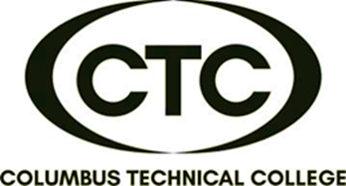

Do you need to improve communication at work, home or socially? This course is designed to teach simple Spanish phrases and Spanish survival skills. (Beginning Level)

6:00 pm – 8:00 pm

Tuesday & Thursday

CTC Training Center

5330 Transport Blvd.

Columbus, GA 31907

**CONTINUING EDUCATION CERTIFICATE**

**cONVERSATIONAL sPANISH**



**24-Hour Course**

**(10 Sessions)**

**\*\***

**DATES:**

**June 6 & 8**

**Jun 14 & 15**

**June 20 & 22**

**June 27 & 29**

**July 11 & 13**

**July 18 & 20**



**$235/person**

**Book/Material Provided**

**(25 contact hours)**

For more information or to register,

call Deana Beauford at **706-649-1454**

or email [**dbeauford@columbustech.edu**](mailto:dbeauford@columbustech.edu)