|  |
| --- |
|  |
|  |

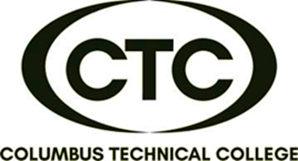

**This American Sign Language introductory course is designed to minimize communication barriers with individuals who are hard of hearing or deaf. It includes fundamentals such as fingerspelling, numbers, vocabulary, and grammar. At the end of the course, participants will be proficient in visual /gestural communication and have basic conversational skills.**

Start date: June 4th

Tuesday & Thursday

6:00 pm – 8:00 pm

5330 Transport Blvd.

Columbus, GA 31907

**CONTINUING EDUCATION CERTIFICATE**

**American Sign Language**

**$235/person**

**(use your previous book )**

**24-Hour Course**

**(12 Sessions for 5 weeks)**

**\*\***

**DATES:**

**June 4 & 6**

**June 11 & 13**

**June 18 & 20**

**June 25 & 27**

**July 9 & 11**

**July 16 & 18**



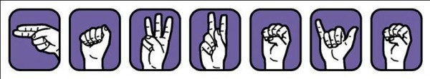

**American Sign Language Level I**

For more information or to register,

call Deana Beauford at **706-649-1454**

or email [**dbeauford@columbustech.edu**](mailto:dbeauford@columbustech.edu)