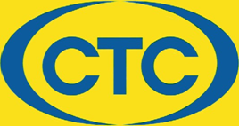
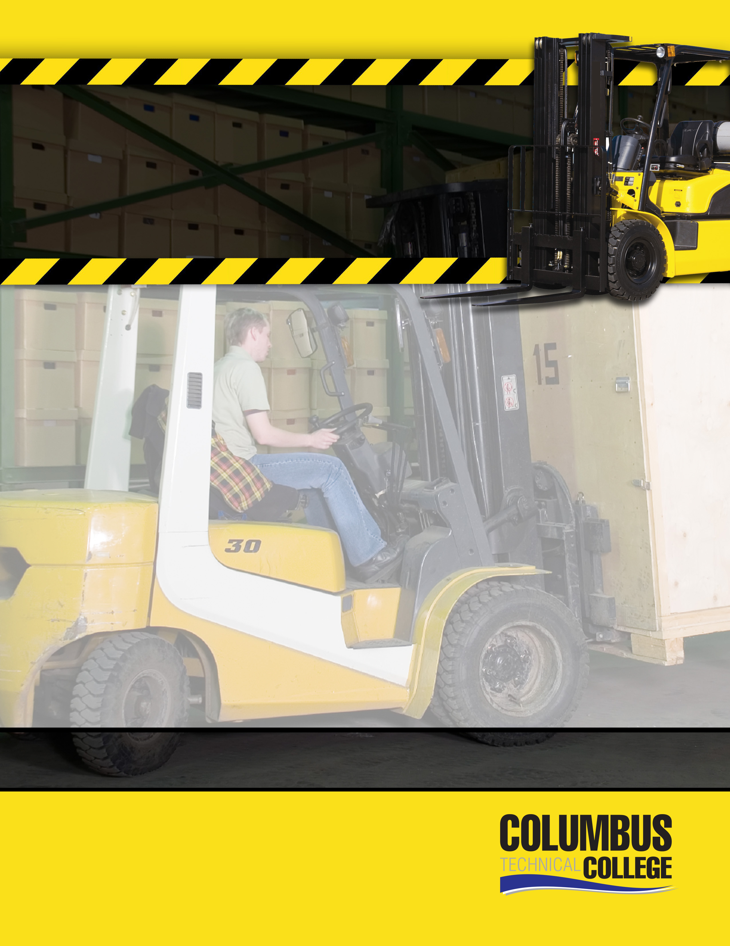
July 18, 2023
August 15, 2023
September 19, 2023
October 17, 2023
November 21, 2023
December 19, 2023
8:30 AM – 2:00 PM
January 25, 2023
February 21, 2023
March 21, 2023
April 18, 2023
May 16, 2023
June 20, 2023

This OSHA compliant course is a comprehensive program for forklift operators in the manufacturing environment. It is designed for individuals requiring the operator skills needed prior to becoming certified by a current or prospective employer.

The program includes classroom instruction and supervised hands-on operation of a forklift.

A Columbus Technical College Certificate of Completion is awarded at the conclusion of the session.

Classes are normally held the third
Tuesday of each month.

Cost: $150.00

Online Registration:
https://columbustech.coursestorm.com/category/forklift-driver-safety

For additional information contact:
Jud Faircloth 706-649-1403 sfaircloth@columbustech.edu
COLUMBUS TECHNICAL COLLEGE

SAFETY &
TRAINING
CERTIFICATE
FORKLIFT
OPERATOR
Columbus Technical College Training CENTER
5330 Transport BlVd. Columbus, GA 31904

