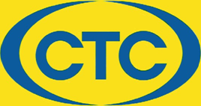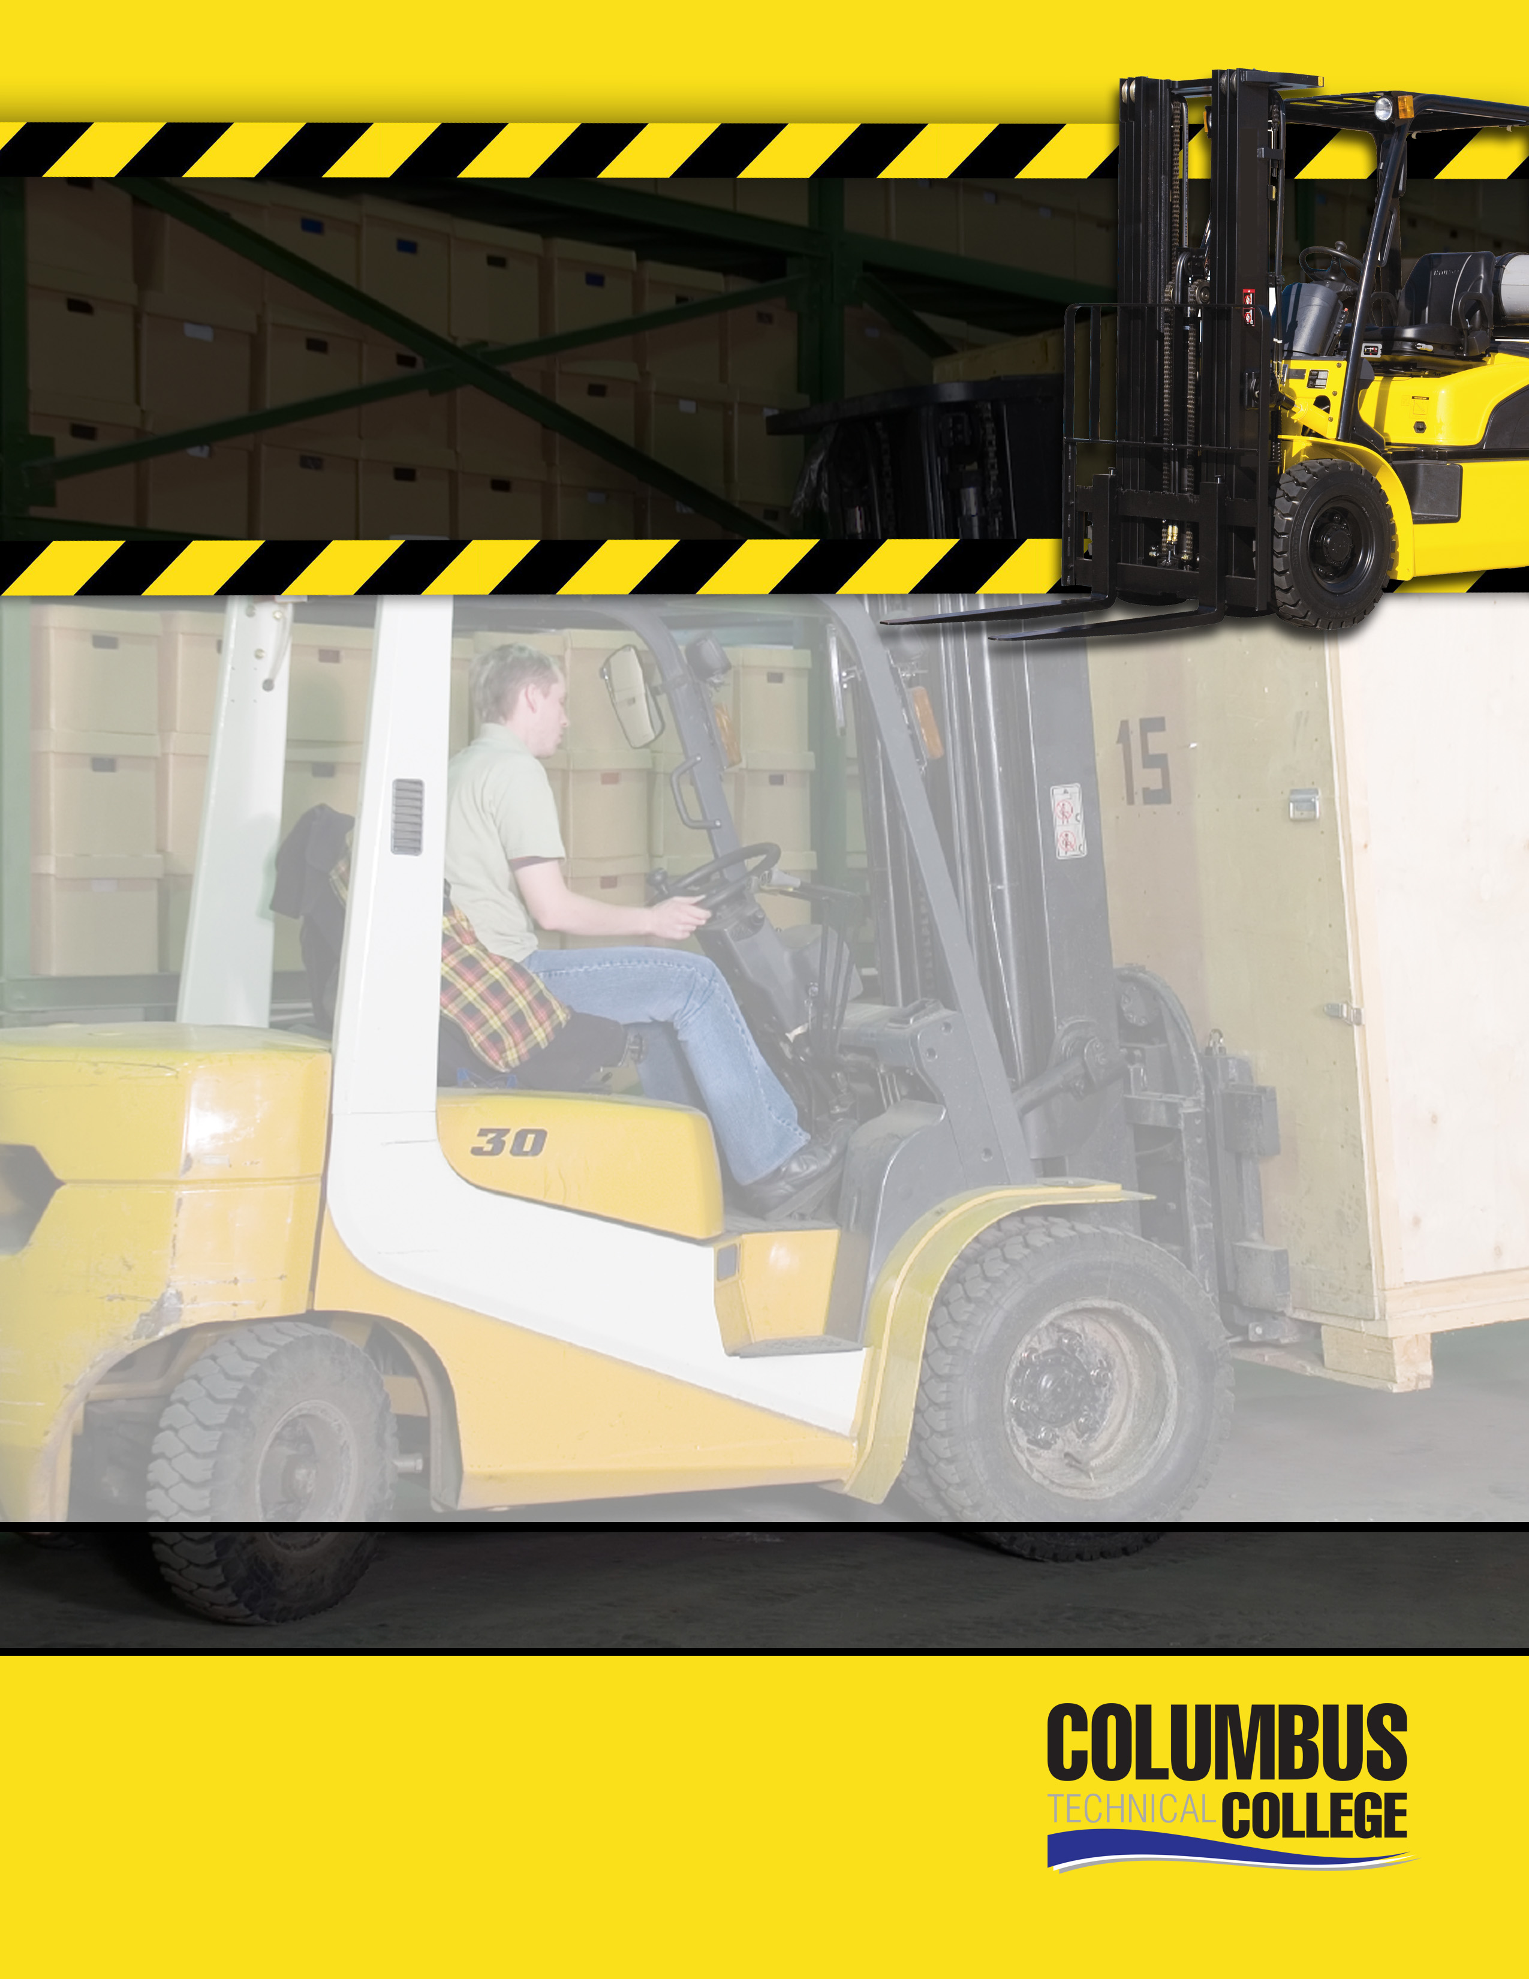

**July TBD,** **2024**

**August TBD, 2024**

**September TBD, 2024**

**October TBD, 2024**

**November TBD, 2024**

**December TBD, 2024**

**8:30 AM – 2:00 PM**

**January 16, 2024**

**February 20, 2024**

**March 19, 2024**

**April 16, 2024**

**May 21, 2024**

**June 18, 2024**

This OSHA compliant course is a comprehensive program for forklift operators in the manufacturing environment. It is designed for individuals requiring the operator skills needed prior to becoming certified by a current or prospective employer.

The program includes classroom instruction and supervised hands-on operation of a forklift.

A Columbus Technical College Certificate of Completion is awarded at the conclusion of the session.

***Classes are normally held on the third***

***Tuesday of each month.***

***Cost: $150.00***

***Online Registration:***

[***https://columbustech.coursestorm.com/category/forklift-driver-safety***](https://columbustech.coursestorm.com/category/forklift-driver-safety)

For additional information contact:

Jud Faircloth 706-649-1403 [sfaircloth@columbustech.edu](mailto:sfaircloth@columbustech.edu)

**COLUMBUS TECHNICAL COLLEGE**

**SAFETY &**

**TRAINING**

**CERTIFICATE**

FORKLIFT

OPERATOR

**Columbus Technical College Training CENTER**

**5330 Transport BlVd. Columbus, GA 31904**