|  |
| --- |
|  |
|  |

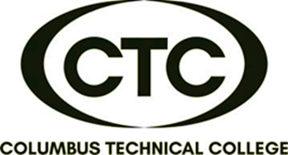

**$99/person**

**(Course only)**

**$339/person**

**(Course + National Exam)**

**Certified Direct Customer Service Professional (DCSP)**

**This program is designed for front-line employees, including call centers, payment centers, information (411/911) centers and receptionist. Program focuses on not only customer interactions, but techniques on delivering quality services, appropriate behaviors in work environment, communication barriers, and positive work ethics.**

 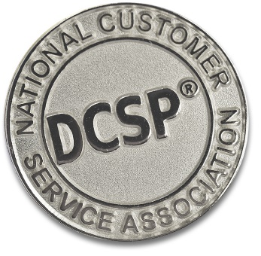

* Foundations of Customer Service
* Drivers of Human Behavior
* Effective Communication Strategies
* Sexual Harassment
* Business Ethics
* 8-hour Course

TBD

**9:00 am – 1:00 pm**

**(Monday – Thursday)**

**CTC Training Center**

**5330 Transport Blvd.**

**Columbus, GA 31907**

**COURSE CONTENT INCLUDES:**



For more information or to register,

call Deana Beauford at **706-649-1454**

or email [**dbeauford@columbustech.edu**](mailto:dbeauford@columbustech.edu)